ANAHESS, A NEW SECOND ORDER SUM OF EXPONENTIALS FIT ALGORITHM, COMPARED TO THE TIKHONOV REGULARIZATION APPROACH, WITH NMR APPLICATIONS
TITLE Times new Roman 14pt All CAPS

First Author ^{1,*}, Second Author², Third Author³, and Last Author⁴

¹ The University of ABC, City, Country
² The University of ABC, City, Country
³ The University of ABC, City, Country
⁴ The University of ABC, City, Country
*Corresponding Author
Doc Margins : Left 1 Right 1
Page size Letter 8.5”*11”

ABSTRACT title Times new Roman 10pt Capital Each Word

ABSTRACT
The problem of fitting a sum of exponentials to second order data is often called the second order (or two dimensional) inverse Laplace transform (2D-ILT). The present work describes ANAHESS, a new inverse Hessian algorithm which handles this ill-posed numerical problem. The algorithm uses numerical expressions for the gradient and the Hessian matrix, and has performed well on various artificial and experimental data sets. The new algorithm is presented in a Nuclear Magnetic Resonance (NMR) context.

Keywords: Sum of exponentials, T₁–T₂ relaxation, Hessian, Bayesian information criterion, Earth mover’s distance.
Section heading Times new Roman 10pt All CAPS
1. INTRODUCTION
2D NMR techniques are Nuclear Magnetic Resonance measurement techniques which produce second order data matrices. Such techniques are a frequently used tool in the characterization of fluid filled porous media, and they have found a wide variety of applications, such as analysis of food products, rock core samples and hydrating cement pastes. In these NMR techniques, the fitting of a sum of exponentials to the measured response surface is a vital tool. Such a fitting is often called the second order Laplace transform (2D-ILT). The goal of 2D-ILT is to transform the data from a sum of exponentially decaying components to a set of parameters characterizing the exponential decay of each component. Depending on the experimental setup, these parameters have a physical interpretation such as spin-lattice relaxation time T₁, spin-spin relaxation time T₂ or diffusion coefficient D. Although such a transform is notoriously ill conditioned numerically [1], algorithms that attempt to perform this transform are in widespread use [2-5].

2. PROBLEM FORMULATION
Assume an experiment which produces a second order matrix R having NSA (number of samples) rows and NSE (number of sensors) columns. Assume also that the measured response is the linear sum of NCO different components, each component decaying exponentially with both the row index and the column index. The row-wise exponential decay follows an axis g_{i}, i=1..NSA, contained in a vector g of size NSA, while the column-wise exponential decay follows an axis t_{j}, j=1..NSE, contained in a vector t of size NSE. Each component is assumed to exhibit a row-wise decay with a characteristic parameter T_{1,p}, p=1..NCO, while the component’s column-wise decay is assumed to have a characteristic parameter T_{2,p}, p=1..NCO. The magnitude of each component is determined by a factor a_{p}, p=1..NCO, while any permanent signal offset present is assigned to the variable a₀. The spacing between subsequent element in g and t may or may not be constant. Any element R_{i,j}, i =1..NSA, j =1..NSE in R is then assumed to follow the function as shown in Table 1.

3.1. The Univariate Minimization
Each iteration in an inverse Hessian algoritm requires an univariate minimization along the search direction of -H(x_{k})⁻¹ ∇(x_{k}). In the present MATLAB [13] implementation of ANAHESS, this is done using the routine fminbnd, which is based on golden section search and parabolic interpolation [12]. In the present implementation, the optimal step length φ is always somewhere between a minimum of 10⁻²⁰ and a maximum of 20. Also, if the solution strays outside of the interval defined by the minima and maxima of g and t, F is given a very high value as given in Figure 1.

Table 1. Name
Response surface  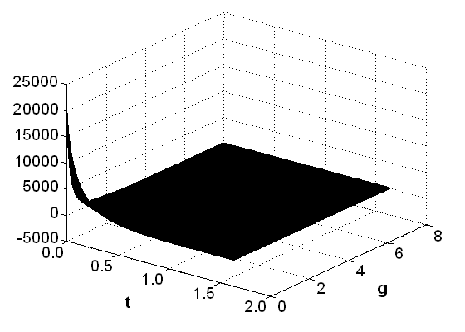
  Core diameter | 1.5 inches
  Temperature during experiment | 308 K
  Instrument provider | Resonance¹
  Laboratory location | Anvendt teknologi²
  Frequency | 12 MHz
  g_{min}..g_{max} | 0.0010 .. 8.0 s
  NSA | 20
  t_{min}..t_{max} | 0.000212 .. 1.6415 s
  NSE | 8192

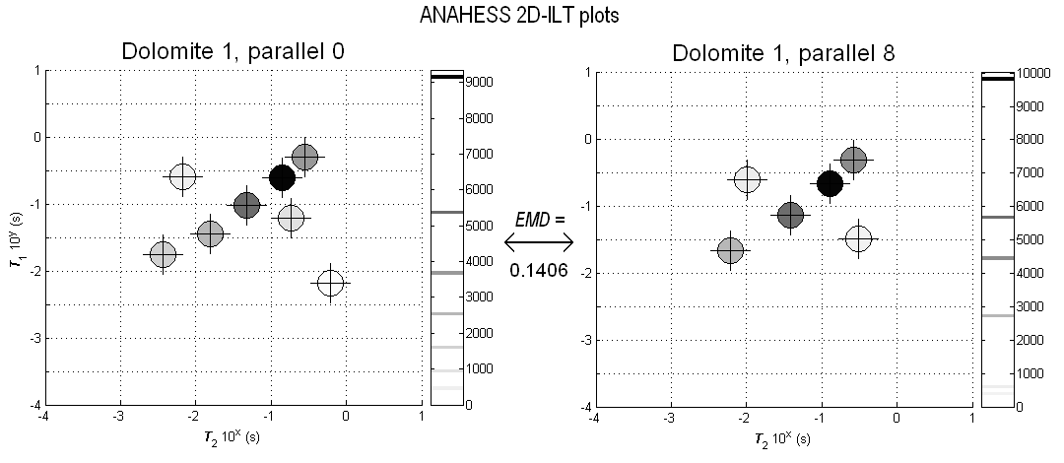

Figure 1.Name

5. CONCLUSIONS
A new algorithm called ANAHESS for the second order fit of a sum of exponentials has been devised and implemented. The algorithm is an inverse Hessian algorithm using analytical expressions for both the gradient and the Hessian matrix. The algorithm produces a set of distinct model components, not an approximation to a continuous distribution in T₁ and T₂. The number of components in the model is determined using the Bayesian information criterion. When compared to an established regularization method, the current MATLAB implementation of ANAHESS has performed well. ANAHESS is effective in finding simple models with a low sum of squared residuals.

6. ACKNOWLEDGEMENTS
Add your acknowledgements here.

7. REFERENCES
- F.S.Acton, “Numerical Methods that Work”. The Matematical Association of America, Washington (1990).
- M.D. Hürlimann, L. Burcaw, Y.-Q. Song, Quantitative characterization of food products by two-dimensional D-T₂ and T₁-T₂ distribution in a static gradient, J. Colloid Interface Sci. 297, Issue 1, 303-311 (2006).
- L. Venkataramanan, Y.-Q. Song, M.D. Hürlimann, Solving Fredholm integrals of the first kind with tensor product structure in 2 and 2.5 dimensions, IEEE Trans. Singal Process. 50, 1017-1026 (2002).
- Y.Q. Song, L. Venkataramanan, and M.D. Hürlimann, T₁-T₂ Correlation Spectra Obtained Using a Fast Two-Dimensional Laplace Inversjon, J. Magn. Reson. 154, 261 (2002)
- G.H. Sørland, P.M. Larsen, F. Lundby, A.-P. Rudi, T. Guiheneuf, Determination of total fat and moisture content in meat using low field NMR, Meat Sci. 66, 543-550 (2004).

